Speed - Time Graphs

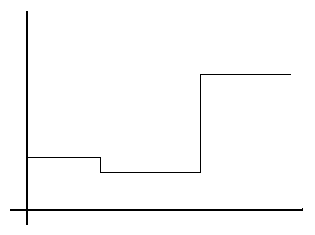
Draw a graph on the board looking like this.

Ask the pupils to suggest what the graph might represent.

Tell them that it represents a car journey and now ask for further suggestions: vertical axis could commonly be distance or speed. Welcome other suggestions and look for interpretations based upon each suggestion.

Take one of the suggestions where axes are time and speed and put some numbers on the axes.

How far is the journey?
Draw a distance - time graph for the same journey.

Discuss how realistic the graph is for a journey
[i.e. the speed doesn't change instantaneously but gradually, maybe straight maybe a curve]

Conor is taking part in a race, he runs at a steady 5ms⁻¹ for the first 12 seconds and then slows down to 4ms⁻¹ for the next 21 seconds and finally he sprints at 8ms⁻¹ for the final 7 seconds.

Hannah travels along the motorway at 80mph for 2 hours before being stopped by the police for 30 minutes. She then continues her journey for the next 2 hours at a steady 60mph.

James decides that it is time that he got fit and decides to go out for a jog. He begins running at a respectable 6ms-1 but after about 15 seconds he decides to slow down a bit and jogs at 4ms-1 for the next 30 seconds. Struggling for breath he slowly limps in at 2ms⁻¹ for the last 5 seconds feeling all the better for the exercise.

Discuss as to whether straight-line graphs are appropriate and ask for suggestions as to when this would not be so.

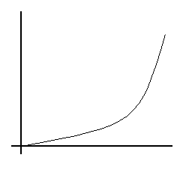Look at the distance travelled over
1 second intervals by treating as trapezia and further discuss the criteria for when it is curved.

Fit a story to this graph and estimate the distance traveled during the journey, by splitting the
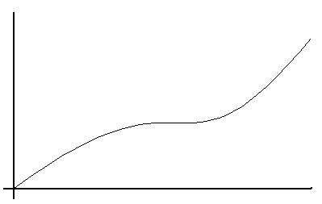area beneath the curve into trapezia.

Then look at the meaning of curves on a distance - time graph.

